Design and apply context-aware access controls based on user identity, device posture, location, and application risk

TEAM DETAILS

College: KPR College of Arts Science and Research
College Code: bruaz

S.No | Name | College | Email
1 | Santhiya L | KPR College of Arts Science and Research | 23bit054@kprcas.ac.in
2 | Sujith M | KPR College of Arts Science and Research | 23bit057@kprcas.ac.in
3 | Rajesh Kumar P | KPR College of Arts Science and Research | 23bit045@kprcas.ac.in
4 | Naren Ram L | KPR College of Arts Science and Research | 23bit036@kprcas.ac.in

INTRODUCTION

In today’s rapidly evolving digital environment, organizations are increasingly exposed to sophisticated cyber threats and security breaches. As businesses adopt cloud computing, remote work environments, and mobile technologies, the traditional methods of protecting corporate networks are no longer sufficient. Cyber attackers constantly exploit vulnerabilities in outdated security architectures, making it essential for organizations to implement modern and intelligent security solutions that can detect, prevent, and respond to threats effectively.

Historically, many organizations relied on the perimeter-based security model, often referred to as the “castle-and-moat” approach. In this model, users inside the corporate network were automatically trusted, while external users were considered untrusted. However, with the widespread adoption of cloud applications, remote working models, and Bring Your Own Device (BYOD) policies, the traditional network perimeter has effectively disappeared. Employees now access corporate applications from multiple locations, networks, and devices, making the conventional security model inadequate for protecting sensitive organizational resources.

To address these challenges, modern cybersecurity strategies have shifted towards the Zero Trust security model, which operates on the principle of “never trust, always verify.” Instead of assuming that users inside a network are trustworthy, Zero Trust continuously validates every access request based on multiple contextual factors such as user identity, device health, location, and the sensitivity of the requested application. This approach significantly reduces the risk of unauthorized access, data breaches, and insider threats.

This project focuses on implementing least-privilege access control using identity-aware and application-specific access policies through Zscaler Private Access (ZPA). ZPA is a cloud-delivered Zero Trust Network Access (ZTNA) solution that allows organizations to provide secure access to private applications without exposing them to the public internet. Unlike traditional VPN-based access, ZPA connects users directly to specific applications rather than the entire network, ensuring that users can only access the resources necessary for their roles.

The proposed system evaluates multiple contextual parameters before granting access, including user identity, role-based permissions, device security posture, geographical location, and the risk level associated with the requested application. Based on these factors, the system dynamically determines the appropriate level of access. For instance, the system may grant full access, limit certain functionalities, require additional authentication such as multi-factor authentication (MFA), or completely block the request if suspicious behavior is detected.

By implementing context-aware and identity-driven access policies, this project aims to enforce the principle of least privilege, ensuring that users receive only the minimum level of access required to perform their tasks. This approach minimizes the attack surface, prevents lateral movement within networks, and significantly enhances organizational security.

Ultimately, the goal of this project is to demonstrate how modern Zero Trust technologies such as Zscaler Private Access (ZPA) can provide a secure, scalable, and frictionless access experience for users while protecting critical organizational resources. By intelligently evaluating access requests in real time, organizations can maintain a strong security posture while enabling productivity for a modern, distributed workforce.

ABSTRACT
The rapid growth of cloud computing, mobile devices, and hybrid work environments has transformed how organizations access and manage their digital resources. However, these advancements have also weakened the traditional network perimeter, making conventional security models less effective. Employees and users now access organizational applications from different locations, devices, and networks, which increases the risk of cyber threats such as unauthorized access, compromised endpoints, and insider attacks. As a result, traditional access control methods that rely on static policies or simple allow/deny decisions are no longer sufficient to protect sensitive organizational data.
To address these challenges, organizations are adopting modern security frameworks based on the Zero Trust model, which follows the principle of never trust, always verify. This project focuses on implementing a context-aware and identity-based access control system using Zscaler Private Access (ZPA). The system evaluates multiple contextual factors such as user identity, device security posture, geographical location, and the risk level of the requested application before granting access.
The proposed solution enforces least-privilege access policies, ensuring that users are allowed to access only the applications required for their specific roles. By defining granular and application-specific access rules, the system dynamically determines whether an access request should be granted, restricted, or denied. For example, a trusted employee accessing a low-risk application from a secure and managed device may be granted seamless access, while attempts from unknown devices or risky locations may trigger additional verification such as multi-factor authentication (MFA) or access restrictions.
The expected outcome of this project is the development of a secure and adaptive access control framework that minimizes the organizational attack surface. By evaluating access requests in real time and applying intelligent security policies, the system enhances protection while maintaining a smooth user experience. This approach demonstrates how Zero Trust solutions like Zscaler Private Access can enable secure and efficient access to enterprise applications in modern distributed environments.

Use Case Scenarios

Scenario 1: Finance Department Access to ERP System
A senior accountant in the finance department needs to access the corporate Enterprise Resource Planning (ERP) system to process monthly payroll. The user connects from a remote location using their company-managed laptop. Upon launching the ZPA Client Connector, they authenticate via Azure Active Directory with multi-factor authentication (MFA). ZPA evaluates the user's identity, group membership (Finance_ERP_Users), device posture (antivirus active, disk encryption enabled), and connection context. The policy engine determines that the user is authorized and brokers a secure, direct micro-tunnel to the ERP application only. The user can interact with the ERP interface but has no visibility or network-level access to any other internal systems.
Output:
• User authenticated and authorized based on identity and group membership
• Direct micro-tunnel established specifically to the ERP application
• All other internal applications and network segments remain invisible and inaccessible

Scenario 2: Developer Access to Internal Git Repository
A software developer needs to access the organization's internal Git repository to push code updates. The developer connects from a corporate laptop through the ZPA Client Connector and authenticates using their corporate identity credentials. ZPA verifies that the user belongs to the Development_Team group and checks device compliance, including operating system updates and endpoint protection status. After validating these conditions, ZPA creates a secure connection only to the Git server. Even though the repository is hosted inside the internal network, it remains completely hidden from the public internet. The developer can perform Git operations but cannot access databases, HR systems, or other internal applications.
Output:
• Identity verification confirms membership in Development_Team group
• Secure application-level access granted only to the Git repository
• Other internal infrastructure remains completely hidden and unreachable

Scenario 3: HR Manager Access to Employee Management Portal
An HR manager needs to access the internal employee management portal to update employee records. The user logs in through the ZPA Client Connector from a corporate office network using a company-managed device. ZPA verifies the user’s role (HR_Manager), confirms device compliance, and checks if the access request originates from an approved geographic region. Since the conditions meet the security policy, ZPA grants secure access to the HR portal. The user is restricted from accessing unrelated applications such as financial systems or engineering tools.

Output:
• HR manager authenticated and validated based on identity and role
• Secure access granted exclusively to the HR management application
• Access to finance, development, and other systems is restricted

Scenario 4: Contractor Access to Project Management Tool
An external contractor is hired to assist with a short-term project and needs access to the organization's internal project management tool. The contractor logs in using a federated identity provided by the organization. ZPA policies restrict the contractor’s access to only the specific project management application and enforce strict security checks such as MFA and limited session duration. Since the contractor is using a personal device, ZPA allows access only to the required application and blocks access to all other internal resources. Once the project is completed, the contractor's access can be revoked instantly by removing their identity group membership.
Output:
• Contractor authenticated using federated identity with MFA
• Access limited strictly to the project management application
• No visibility or connectivity to other internal corporate systems

Scenario 5: Suspicious Access Attempt from Untrusted Location
A legitimate employee attempts to access a sensitive internal database from an unknown location using an unmanaged device. When the user initiates access through the ZPA Client Connector, the system evaluates contextual signals such as device posture, geographic location, and application sensitivity. Since the device does not meet security compliance requirements and the location is flagged as unusual, the policy engine denies the connection request. The internal database remains completely hidden from the user.
Output:
• Access request evaluated based on device posture and location risk
• Connection denied due to policy violation and security concerns
• Sensitive internal application remains invisible and protected

Stage – 1

Title:

Design and apply context-aware access controls based on user identity, device posture, location, and application risk.

Overview
As organizations adopt cloud technologies, remote work, and mobile devices, the traditional network boundary has become less relevant. In the past, security models relied heavily on VPN-based access where users connected to the internal network and were implicitly trusted once authenticated. This model often resulted in users receiving broad network access, which increased the chances of unauthorized access, internal threats, and lateral movement across systems if credentials were compromised. Modern security strategies must therefore move beyond location-based trust and focus on verifying every access request based on identity and context.
This project addresses these challenges by implementing a Zero Trust architecture that follows the principle of “never trust, always verify.” Instead of granting access simply because a user is connected to the corporate network, the system evaluates multiple factors before allowing access to applications. These factors include the user’s identity, role, device posture, and other contextual information that help determine whether the access request should be permitted.
The solution utilizes Zscaler Private Access (ZPA), a cloud-delivered platform that provides secure, identity-aware access to private applications. Unlike traditional VPN solutions, ZPA does not place users directly on the corporate network. Instead, it establishes a secure connection only to the specific application the user is authorized to access. Internal applications remain hidden from the public internet, which helps prevent common attack techniques such as network scanning or unauthorized discovery of internal resources.
Through this approach, the project enforces a least-privilege access model, where users and devices receive only the minimum level of access required to perform their tasks. Because access is limited to individual applications rather than the entire network, users cannot move laterally between systems. This significantly reduces the potential attack surface while improving overall security. At the same time, the architecture simplifies access management and provides a more efficient and secure way for users to access organizational resources in modern distributed environments.

List of Vulnerability:

S. No. | Vulnerability Name | CWE Number
1 | Relative Path Traversal | CWE-23
2 | Active Debug Code | CWE-489
3 | Software Supply Chain Compromise | CWE-829
4 | Weak Cryptographic Implementation | CWE-327
5 | SQL Injection in Hibernate Queries | CWE-564
6 | Missing Encryption of Sensitive Data | CWE-311
7 | Use of Hard-coded Password | CWE-259
8 | Inclusion of Functionality from Untrusted Control Sphere | CWE-829
9 | Improper Output Neutralization for Logs (Log Injection) | CWE-117
10 | NULL Pointer Dereference | CWE-476

REPORT: -

Vulnerability Name: Relative Path Traversal

CWE- 23

OWASP Category: A01:2021 – Broken Access Control

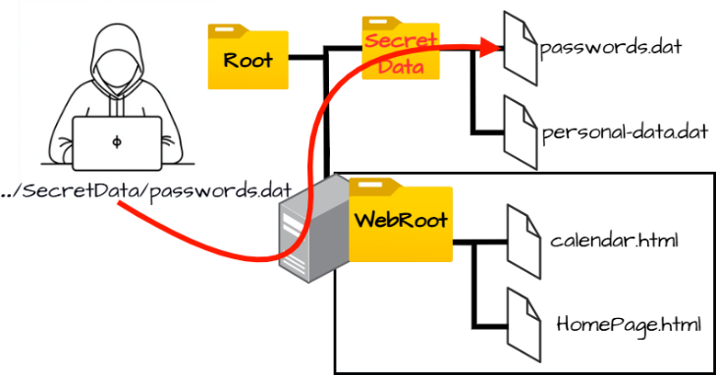
Description: Relative Path Traversal occurs when an application constructs file paths using user input without proper validation, allowing attackers to manipulate directory sequences like “../”, which enables them to move outside the intended directory and access sensitive files on the server.

Business Impact: Attackers can gain unauthorized access to confidential system files, configuration data, or credentials, which may lead to data breaches, system compromise, operational disruption, and significant financial and reputational damage to the organization.

Recommendation:
- Input Validation: Validate and sanitize all user inputs used in file paths and allow only predefined safe values.
- Path Canonicalization: Normalize and verify file paths to remove traversal sequences such as “../” before accessing files.
- Access Control Restrictions: Restrict file access to specific directories and enforce strict file permissions to prevent unauthorized file access.

Vulnerability Name: Active Debug Code

CWE-489

OWASP Category: A02:2021 – Security Misconfiguration

Description: Active Debug Code occurs when a software product is released with debugging or testing code still enabled in the production environment, which can expose internal application behavior and create unintended entry points for attackers, potentially allowing them to manipulate application functions or bypass security controls.
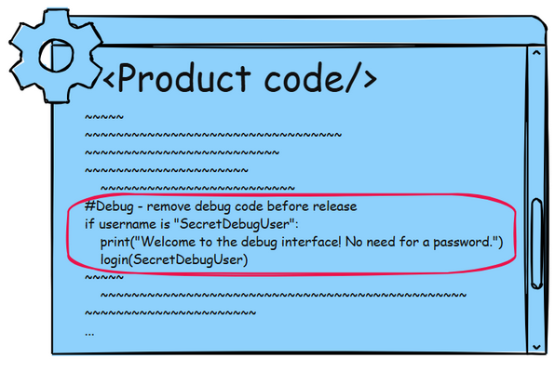
Business Impact: If debug functionality remains active in a deployed system, attackers may exploit it to access sensitive application data, bypass authentication mechanisms, or gain elevated privileges, which could ultimately lead to full compromise of the application or underlying server infrastructure.

Recommendation:

- Remove Debug Code Before Deployment: Ensure that all debugging functions, testing endpoints, and development backdoors are completely removed or disabled before deploying the application to production environments.
- Implement Secure Configuration Management: Adopt strict configuration management practices to ensure that debug modes, logging levels, and development settings are not enabled in production systems.
- Perform Security Testing and Code Review: Conduct static code analysis, penetration testing, and security reviews to detect leftover debug code and other insecure development artifacts before releasing the application.

Vulnerability Name: Software Supply Chain Compromise

CWE-829

OWASP Category: A03:2025 – Software Supply Chain Failures

Description: Software supply chain failures occur when an application relies on third-party libraries, dependencies, or components that contain vulnerabilities or malicious code, which can compromise the security of the entire system.
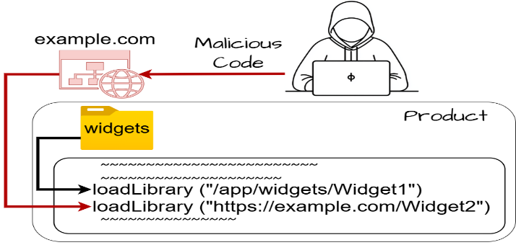
Business Impact: Attackers may inject malicious code through compromised dependencies, leading to system compromise, data theft, and large-scale attacks affecting multiple organizations.

Recommendation:

- Dependency Verification: Use trusted repositories and verify the integrity of third-party libraries before including them in the application.
- Regular Dependency Updates: Continuously update and patch third-party components to reduce exposure to known vulnerabilities.
- Supply Chain Monitoring: Use automated tools to scan and monitor software dependencies for security risks.

- Vulnerability Name: Weak Cryptographic Implementation

CWE - 327

OWASP Category: A04:2025 – Cryptographic Failures

Description: Cryptographic failures occur when sensitive data is protected using weak encryption algorithms, improper key management, or insecure transmission mechanisms.
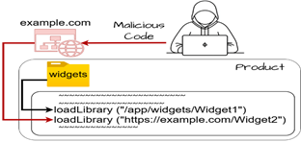
Business Impact: Weak encryption may allow attackers to decrypt confidential data such as passwords, financial information, or personal records.

Recommendation:
- Use Strong Encryption: Implement modern encryption standards such as AES-256 and TLS 1.3 to secure sensitive data.
- Secure Key Management: Store cryptographic keys securely and rotate them periodically to prevent misuse.
- Encrypt Sensitive Data: Ensure that all sensitive data is encrypted both in transit and at rest.

Vulnerability Name: SQL Injection in Hibernate Queries
CWE-564
OWASP Category: A05:2025 – Injection
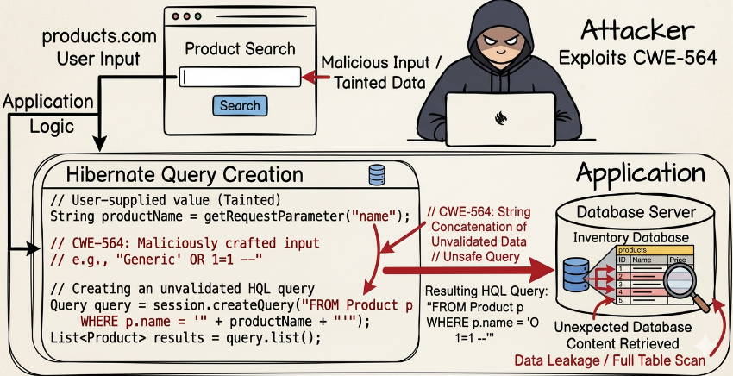
Description: SQL Injection in Hibernate occurs when an application builds Hibernate Query Language (HQL) statements using unvalidated user input, allowing attackers to manipulate the query structure and execute unauthorized database commands through the Hibernate framework.

Business Impact: Attackers may retrieve, modify, or delete sensitive database records, potentially leading to data breaches, unauthorized access to user information, and compromise of the entire application database.
Recommendation:
- Use Parameterized Queries: Always use parameter binding in Hibernate queries to prevent user input from being interpreted as executable query code.
- Input Validation: Validate and sanitize all user inputs before using them in HQL queries to ensure that malicious characters or commands are rejected.
- Least Privilege Database Access: Configure database accounts with minimal privileges so that even if an injection occurs, the attacker cannot perform critical operations.

Vulnerability Name: Missing Encryption of Sensitive Data

CWE – 311

OWASP Category: A04:2025 – Cryptographic Failures
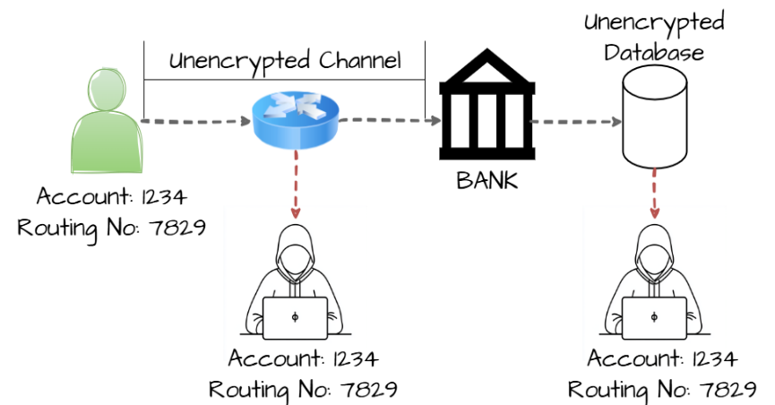
Description: This vulnerability occurs when sensitive information such as passwords, personal data, or financial details is stored or transmitted without proper encryption, making it accessible to unauthorized parties who may intercept or access the data.

Business Impact: Attackers may capture or read sensitive data through network interception or unauthorized system access, which can lead to data breaches, identity theft, financial loss, and reputational damage for the organization.

Recommendation:

- Encrypt Sensitive Data: Use strong encryption algorithms such as AES or TLS to protect sensitive data during storage and transmission.
- Secure Communication Channels: Ensure that all data exchanges occur over secure protocols like HTTPS instead of insecure protocols such as HTTP.
- Proper Key Management: Store and manage encryption keys securely and rotate them periodically to prevent unauthorized access.

Vulnerability Name: Use of Hard-coded Password

CWE- 259

OWASP Category: A07- 2025 – Authentication Failures

Description: This vulnerability occurs when a password is directly embedded in the application source code or configuration files, allowing anyone who gains access to the code to easily discover and use the credentials to access the system.
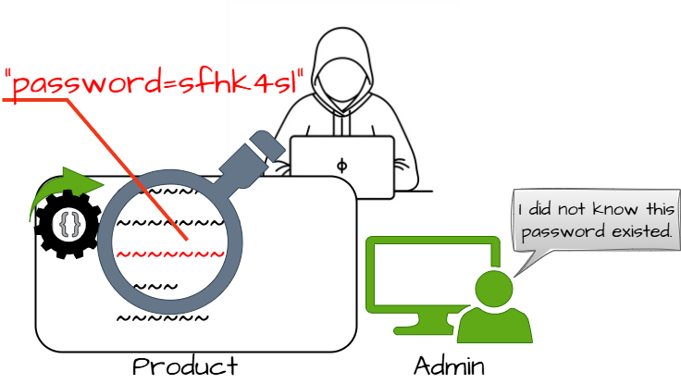
Business Impact: Attackers who obtain the hard-coded password may gain unauthorized access to applications, databases, or administrative functions, potentially leading to data breaches, system compromise, and loss of sensitive information.

Recommendation:

- Use Secure Credential Storage: Store passwords securely using environment variables or dedicated secret management systems instead of embedding them in source code.
- Implement Strong Authentication: Use secure authentication mechanisms such as token- based authentication or multi-factor authentication to reduce reliance on static passwords.
- Regular Credential Rotation: Frequently change passwords and remove hard-coded credentials from the application to minimize the risk of unauthorized access.

Vulnerability Name: Inclusion of Functionality from Untrusted Control Sphere

CWE- 829

OWASP Category: A03:2025 – Software Supply Chain Failures

Description: This vulnerability occurs when an application loads or executes code from external or untrusted sources without proper validation, which may allow attackers to introduce malicious components into the system.

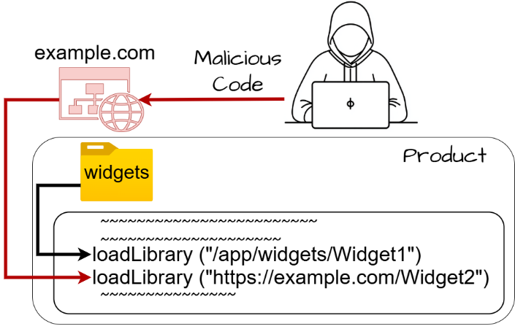
Business Impact: Attackers can inject malicious libraries or scripts into the application, leading to unauthorized code execution, system compromise, or large-scale supply chain attacks affecting multiple systems.

Recommendation:

- Validate External Sources: Ensure all external libraries and modules are obtained from trusted repositories and verified before use.
- Implement Integrity Checks: Use digital signatures or hash verification to confirm that external components have not been tampered with.
- Limit External Code Execution: Restrict the application from dynamically loading code from unknown or untrusted sources.

Vulnerability Name: Improper Output Neutralization for Logs (Log Injection)

CWE- 117

OWASP Category: A09:2025 – Security Logging and Alerting Failures
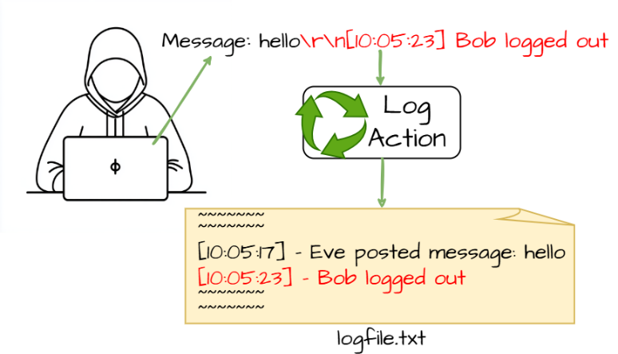
Description: This vulnerability occurs when user-controlled input is written directly to log files without proper sanitization, allowing attackers to manipulate log entries or inject malicious content.

Business Impact: Attackers can alter or forge log records, hide malicious activities, or inject misleading information, which may disrupt security monitoring and incident investigations.

Recommendation:

- Sanitize Log Inputs: Filter or encode user input before writing it to log files to prevent injection attacks.
- Use Structured Logging: Implement standardized logging formats that prevent manipulation of log entries.

- Protect Log Integrity: Restrict access to log files and implement monitoring to detect unauthorized changes.

10) Vulnerability Name: NULL Pointer Dereference

CWE- 476

OWASP Category: A10:2025 – Mishandling of Exceptional Conditions

Description: This vulnerability occurs when a program attempts to access or dereference a pointer that has a NULL value, which may cause the application to crash or behave unpredictably.
Business Impact: Exploiting this vulnerability may result in system crashes, denial of service, or instability of the application, affecting availability and reliability of the system.
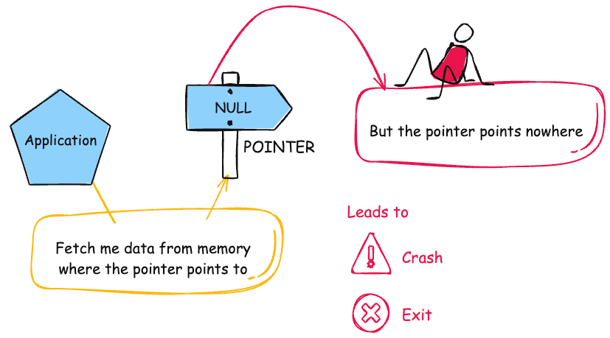
Recommendation:

1. Validate Pointers Before Use: Always check whether a pointer is NULL before accessing it in the program.
2. Implement Proper Exception Handling: Use error handling mechanisms to manage unexpected conditions safely.
3. Perform Secure Code Reviews: Conduct regular code reviews and testing to detect and fix potential NULL pointer issues.

STAGE – 2

TITLE: NESSUS SCAN

Overview : -

Nessus is a robust vulnerability assessment tool developed by Tenable, Inc. designed to identify security gaps across an organization's infrastructure. It operates as a remote scanner, which means it probes target hosts over the network without requiring any software installation on the targets themselves. By sending a diverse array of probes—including network traffic patterns, operating system commands, and specific application requests—Nessus can accurately map out an attack surface and pinpoint potential entry points for attackers.

The power of Nessus lies in its plugin-based architecture, which allows for frequent updates to keep pace with new threats. Plugins are modular scripts designed to detect specific vulnerabilities, and Nessus currently utilizes over 210,000 of them to cover a massive range of operating systems, network devices, and software applications. This system ensures that the scanner remains versatile, whether it is checking for a decade-old bug or a zero-day exploit released just hours ago.

When performing a web page scan, Nessus utilizes a dedicated Web Application Scanning (WAS) engine to navigate the complexities of modern sites. The process begins with a discovery phase where Nessus crawls the URL to map out the site's structure, including hidden directories and API endpoints. It then runs targeted plugins to test for web-specific flaws like SQL Injection or Cross-Site Scripting (XSS). Once the scan is complete, Nessus generates a prioritized report that details each vulnerability's severity, evidence of the flaw, and clear remediation steps to help developers secure the page.

Nessus can be used to scan a variety of targets, including single hosts, networks, and web applications. It can also be used to scan specific ports and services. Nessus can be configured to run scans on a schedule or manually.

Here is a step-by-step explanation of how Nessus works:

- Nessus connects to the target host using a variety of protocols, including TCP, UDP, and ICMP.
- Nessus sends a series of probes to the target host in order to identify its operating system and services.
- Nessus runs a series of plugins to test for vulnerabilities.
- Nessus generates a report that includes the severity of each vulnerability, the steps to reproduce the vulnerability, and the steps to remediate the vulnerability.

Nessus is a valuable tool for security professionals who need to identify and remediate vulnerabilities in their networks. It is easy to use and provides comprehensive reports that can be used to prioritize remediation efforts.

Here are some of the benefits of using Nessus:

- Comprehensive vulnerability coverage: Nessus has over 1200 plugins available, covering a wide range of vulnerabilities in operating systems, applications, and network devices.
- Easy to use: Nessus has a user-friendly interface that makes it easy to configure and run scans.
- Comprehensive reporting: Nessus provides detailed reports that include the severity of each vulnerability. the steps to reproduce the vulnerability, and the steps to remediate the vulnerability.
- Scalability: Nessus can be used to scan a variety of targets, including single hosts, networks, and web applications.
- Flexibility: Nessus can be configured to run scans on a schedule or manually.

Nessus is a powerful tool that can be used to improve the security of any network. It is a valuable asset for any security professional.

Target website : - https://ginandjuice.shop/
Target ip address: - 34.249.203.140

List of Vulnerability: -

S. No | Vulnerability Name | Severity | Plugin
1 | HSTS Missing From HTTPS Server (RFC 6797) | Medium | 142960
2 | SSL Certificate Information Disclosure | Info | 10863
3 | SSL/TLS Recommended Cipher Suites | Info | 56984
4 | TLS NPN Supported Protocol Enumeration | Info | 87242
5 | Web Server Crafted Request Vendor/Version Information Disclosure | Info | 11239
6 | Service Detection | Info | 22964
7 | Nessus SYN Scanner | Info | 11219
8 | Nessus Scan Information | Info | 19506
9 | TLS Version 1.2 Protocol Detection | Info | 136318
10 | HyperText Transfer Protocol (HTTP) Information | Info | 24260

REPORT: -

- Vulnerability Name: - 142960 - HSTS Missing From HTTPS Server (RFC 6797)
Severity: - MEDIUM
Plugin: - 142960

Port: - 443/TCP
Description: - The remote web server is not enforcing HSTS, as defined by RFC 6797. HSTS is an optional response header that can be configured on the server to instruct the browser to only communicate via HTTPS. The lack of HSTS allows downgrade attacks, SSL-stripping man-in-the-middle attacks, and weakens cookie-hijacking protections.

Solution: - Configure the remote web server to use HSTS.
Business Impact: - The absence of HSTS makes the website vulnerable to downgrade and man-in-the-middle attacks, allowing attackers to intercept or manipulate user communications. Sensitive information such as login credentials and session cookies may be exposed during insecure HTTP connections. This can lead to unauthorized account access and data breaches. As a result, the organization may face loss of user trust, reputational damage, and potential compliance issues.

- Vulnerability Name: -10863-SSL Certificate Information Disclosure
Severity: - INFO
Plugin: - 10863

Port: - 443/TCP
Description: - The plugin connects to the SSL service and retrieves the X.509 certificate information used by the server. It displays details such as issuer, validity period, encryption algorithm, and key length. This is mainly used for informational and verification purposes.
Solution: - Ensure that the SSL certificate is valid, uses strong encryption, and is renewed before expiration. Regular certificate monitoring is recommended.
Business Impact: - This finding is informational but may reveal certificate and server configuration details. Attackers could use this information during reconnaissance. Proper certificate management helps maintain secure communication.

Vulnerability Name: - 56984 - SSL/TLS Recommended Cipher Suites-

Severity: - INFO
Plugin: - 56984

Port: - 443
Description: - The remote host has open SSL/TLS ports which advertise discouraged cipher suites. It is recommended to only enable support for the following cipher suites
Solution: - Only enable support for recommened cipher suites.

Business Impact: - If weak cipher suites are enabled, attackers may exploit them to weaken encrypted communications. This can lead to potential data interception or cryptographic attacks. Using strong cipher suites ensures secure data transmission and improves system security.

Vulnerability Name: - 87242 - TLS NPN Supported Protocol Enumeration

Severity: - INFO
Plugin: - 87242

Port: - 443/TCP
Description: - The plugin checks whether the server supports TLS Next Protocol Negotiation (NPN). It enumerates the protocols that the server can negotiate during the TLS handshake. This information helps identify the protocols supported by the server for secure communication.
Solution: - Review the supported protocols and ensure only secure and required protocols are enabled. Disable outdated or unnecessary protocols to reduce the attack surface. Regularly update TLS configurations to follow security best practices.
Business Impact: - Although informational, exposed protocol details may assist attackers during reconnaissance. Knowledge of supported protocols can help attackers identify potential weaknesses. Proper configuration reduces the risk of protocol-based attacks.

5) Vulnerability Name: - 11239 - Web Server Crafted Request Vendor/Version Information Disclosure

Severity: - INFO
Plugin: - 11239

Port: - 443/TCP
Description: - The web server running on the remote host appears to be hiding its version or name, which is a good thing. However, using a specially crafted request, Nessus was able to discover the information.
Solution: - No generic solution is known. Contact your vendor for a fix or a workaround.
Business Impact: - Disclosure of server vendor and version information may assist attackers in identifying known vulnerabilities. Attackers can use this information to plan
targeted attacks against the system. Hiding server details helps reduce the risk of reconnaissance-based attacks.

6) Vulnerability Name: - 22964 - Service Detection

Severity: - INFO
Plugin: - 22964

Port: - 80
Description: - Nessus was able to identify the remote service by its banner or by looking at the error message it sends when it receives an HTTP request.
Solution: - N/A
Business Impact: - Service information disclosure may help attackers understand the system environment. This information can be used during reconnaissance to identify potential attack points. Limiting exposed services reduces the overall attack surface.

7) Vulnerability Name: - 11219 - Nessus SYN scanner

Severity: - INFO
Plugin: - 11219

Port: - 80 (or) 443
Description: - This plugin is a SYN 'half-open' port scanner. It shall be reasonably quick even against a firewalled target. Note that SYN scans are less intrusive than TCP (full connect) scans against broken services, but they might cause problems for less robust firewalls and also leave unclosed connections on the remote target, if the network is loaded.
Solution: - Protect your target with an IP filter.
Business Impact: - Open ports can expose network services to potential attackers. Attackers may use this information to identify entry points for further attacks. Proper port management helps reduce the risk of unauthorized access.

8) Vulnerability Name: - 19506 – Nessus Scan Information

Severity: - INFO

Plugin: - 19506

Port: - N/A
Description: - This plugin provides information about the Nessus scan performed on the target host. It includes details such as the scanner type, Nessus engine version, plugin set version, and the port scanning method used. It also shows scan date, duration, port range scanned, and parallel host/check configuration.
Solution: - No remediation is required since this is an informational plugin. Ensure that scan reports are stored securely and accessible only to authorized personnel.
Business Impact: - This finding does not indicate a vulnerability but provides details about the scanning process. However, exposed scan information could reveal security assessment activities if accessed by unauthorized users. Proper access control for scan reports is recommended.

9) Vulnerability Name: - 136318 - TLS Version 1.2 Protocol Detection

Severity: - INFO
Plugin: - 136318

Port: - 443
Description: - This plugin detects whether the remote service supports TLS version 1.2 for secure communication. TLS 1.2 is a widely used protocol that provides strong encryption and secure data transmission between clients and servers. The result confirms the availability of this protocol on the target system.
Solution: - Ensure that TLS 1.2 or higher versions such as TLS 1.3 are enabled for secure communication. Disable older and insecure protocols like SSL and TLS 1.0/1.1 to improve security.
Business Impact: - Supporting TLS 1.2 improves the security of encrypted communications. However, if older protocols are also enabled, attackers may attempt downgrade attacks. Proper TLS configuration ensures strong data protection.

10) Vulnerability Name: - 24260 - HyperText Transfer Protocol (HTTP) Information

Severity: - INFO
Plugin: - 24260

Port: - 80 (or) 443

Description: - This test gives some information about the remote HTTP protocol - the version used, whether HTTP Keep-Alive is enabled, etc…This test is informational only and does not denote any security problem.
Solution: - Configure the web server to limit unnecessary HTTP methods and hide server information in HTTP headers. Implement proper security configurations to reduce information disclosure.
Business Impact: - Disclosure of HTTP service information may assist attackers in identifying server configurations. Attackers can use this data during reconnaissance to plan further attacks. Restricting unnecessary information improves overall security.
STAGE – 3
Title:
Design and Apply Context-Aware Access Controls Based on User Identity, Device Posture, Location, and Application Risk

Overview
In modern digital environments, organizations face increasing cybersecurity threats due to the growth of cloud computing, remote work, and mobile devices. Traditional security models relied heavily on network-based trust, where users connected through Virtual Private Networks (VPNs) and were granted broad access to internal resources. However, this model creates significant security risks because once users are inside the network, attackers can move laterally and access multiple systems if credentials are compromised.
To overcome these limitations, organizations are adopting the Zero Trust security model, which follows the principle of “never trust, always verify.” Instead of trusting users based on their network location, Zero Trust verifies every access request based on multiple contextual factors.
This project focuses on designing and applying context-aware access controls that evaluate various signals such as user identity, device posture, geographic location, and application

risk level before granting access to enterprise applications. By analysing these contextual

attributes, the system dynamically determines whether access should be allowed, restricted, or denied.
The implementation uses Zscaler Private Access (ZPA), a cloud-delivered Zero Trust Network Access solution that provides secure user-to-application connectivity without exposing internal networks to the public internet. ZPA establishes direct, encrypted connections between authenticated users and specific applications, ensuring that users can only access resources they are authorized to use.
Through this context-aware approach, organizations can enforce least-privilege access, minimize the attack surface, and protect sensitive applications from unauthorized access.

Context-Aware Access Control Model
Context-aware access control is a security mechanism that evaluates multiple contextual parameters before granting access to applications. Instead of relying on static authentication methods, this model continuously analyses different risk factors associated with an access request.
The four primary contextual signals used in this project include:
- User Identity
- Device Posture
- Location and Network Context
- Application Risk Level
Each of these factors contributes to the overall security decision.

User Identity Verification
User identity forms the foundation of context-aware access control. Every access request begins with authentication through an Identity Provider (IdP) such as Microsoft Azure Active Directory or Okta.
When a user attempts to access an application, the Zscaler Client Connector redirects the user to the identity provider for authentication. Multi-factor authentication (MFA) is enforced to strengthen the authentication process.
After successful authentication, ZPA retrieves identity attributes including:
- Username
- Department
- Role
- Group membership
- Access privileges
These attributes allow administrators to create identity-based policies. For example, only users belonging to the Finance Department group can access the payroll application.
This identity-centric approach ensures that access decisions are based on who the user is, rather than where the user is connecting from.

Device Posture Assessment
Even if a user’s identity is valid, a compromised or insecure device can introduce security risks. Therefore, context-aware access control also evaluates the security posture of the device attempting to access the application.
Zscaler integrates with endpoint security and device management tools such as:
- Microsoft Defender
- CrowdStrike
- Sentinel One
- Intune

These integrations allow the system to verify the device’s health and compliance status.
Device posture checks include:
- Operating system patch status
- Antivirus installation and updates
- Disk encryption status
- Firewall configuration
- Detection of rooted or jailbroken devices
If a device fails security checks, the system may deny access or redirect the user to a remediation portal where security issues must be resolved before access is granted.
This ensures that only secure and compliant devices can access critical organizational applications.

Location and Network Context
Another important factor in context-aware access control is the location and network environment from which the user is connecting.
Access requests may originate from different locations such as corporate offices, home networks, public Wi-Fi networks, or international locations. Each of these environments carries a different level of risk.
For example:
- Access from corporate networks may be considered low risk.

- Access from public Wi-Fi networks may require additional verification.
- Access from high-risk geographic regions may be blocked entirely.
By analysing the location and network environment, the system can detect suspicious login attempts and apply stricter security policies when necessary.

Application Risk Classification
Not all applications have the same level of sensitivity. Therefore, applications are categorized based on their risk level and business importance.
Applications may be classified as:
Low-Risk Applications:
• Internal knowledge portals
• Employee directories
• General information systems
Medium-Risk Applications:
• Internal collaboration tools
• File sharing systems
• Department portals
High-Risk Applications:
• Financial systems
• Customer databases
• Source code repositories
• Research data systems
Access policies are applied according to the risk level of each application. High-risk applications require stricter access controls such as stronger authentication and fully compliant devices.
This risk-based approach ensures that critical business assets receive the highest level of protection.

Policy Design Using Zscaler Private Access
Zscaler Private Access provides a policy engine that allows administrators to create granular access rules based on contextual attributes.
Policies are defined using logical conditions that combine identity, device posture, location, and application risk.
Example Policy 1:
Allow access to the Internal Wiki Application if:
- User belongs to the Employee group
- Device posture is compliant
- Location is not restricted
Example Policy 2:
Allow access to the Financial Database if:
- User belongs to the Finance Department
- Device posture is fully compliant
- Access request originates from a trusted location
- Multi-factor authentication is verified
These policies enable organizations to create a dynamic security environment where access decisions adapt to the context of each request.

Implementation Approach
The implementation of context-aware access control using Zscaler ZPA follows several key steps.
Step 1: Application Discovery
Identify all internal applications that require secure access.

Step 2: User Segmentation
Group users based on roles and responsibilities such as students, faculty, administrators, and IT staff.
Step 3: Identity Integration
Connect Zscaler with the organization’s identity provider to enable authentication and MFA.
Step 4: Device Posture Integration
Integrate endpoint security tools to monitor device health and compliance.
Step 5: Policy Configuration
Create context-aware policies that define access conditions based on identity, device, location, and application risk.
Step 6: Client Connector Deployment
Install the Zscaler Client Connector on user devices to enable secure application access.

Benefits of Context-Aware Access Control
Implementing context-aware access control provides several security advantages.
- Reduces the attack surface by restricting access to specific applications
- Prevents lateral movement inside the network
- Strengthens authentication using multiple security signals
- Protects sensitive data through risk-based access policies
- Provides better visibility into user activity and access patterns
This approach significantly improves the organization’s overall cybersecurity posture.

Conclusion
Stage 1
focused on identifying web application vulnerabilities using OWASP security standards. Common vulnerabilities such as SQL injection, path traversal, and cryptographic failures were analysed to understand their impact on application security.
Stage 2
Involved performing vulnerability scanning using the Nessus tool. The scan results highlighted security issues such as outdated encryption protocols and misconfigured system settings. Recommendations were provided to improve the security configuration of the system.

Stage 3
Concentrated on designing and applying context-aware access controls using Zero Trust principles. By leveraging Zscaler Private Access, the system verifies user identity, device posture, location, and application risk before granting access. This modern security model replaces traditional network-based trust with identity-centric security, significantly reducing the risk of unauthorized access and cyber-attacks.

Future Scope
The implementation of context-aware access control opens several opportunities for further improvements in cybersecurity.
Future enhancements may include:
- Integration with Secure Access Service Edge (SASE) platforms
- AI-based anomaly detection for identifying suspicious behaviour
- Advanced device risk scoring using endpoint security tools
- Automated access provisioning and revocation based on user roles
- Extending Zero Trust security to cloud workloads and IoT devices
These advancements will further strengthen security and enable organizations to build intelligent and adaptive cybersecurity systems.

Topics Explored
• Zero Trust Security Model
• Context-Aware Access Control
• Identity-Based Security
• Device Posture Verification
• Risk-Based Application Access
• Threat Intelligence
• Incident Response

Tools Explored
- Zscaler Private Access (ZPA)
- Nessus Vulnerability Scanner
- OWASP Security Standards

